**Corner Floating Shelves Wall Mounted Set of 4**

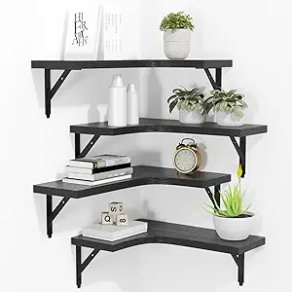 The Corner Floating Shelves Wall Mounted Set of 4 is a practical and stylish solution for maximizing corner spaces in your home. Designed to provide both storage and display space, these shelves offer a modern, minimalist look that helps declutter while enhancing the aesthetics of any room. Made from durable materials like wood, metal, or a combination of both, these shelves are easy to install with the included mounting hardware. Perfect for living rooms, bedrooms, kitchens, or bathrooms, this set allows you to display books, plants, décor, or other items in an efficient, space-saving manner.

.